***LAB no 5***

Muhammad Kaleem

56614

***1. Create Numpy array, split into 3 arrays then calculate sum of all arrays numbers.***

**Code:**

import numpy as np

print(" *******************************************")

print(" Simple NumPy Array")

Array = np.array([1, 2, 3, 4, 5, 6])

print( " " ,Array)

print(" *******************************************")

print("\n")

print(" *******************************************")

print(" Simpliting NumPy Array into 3 Arrays")

New_Array = np.array_split(Array, 3)

print(New_Array)

print(" *******************************************")

print("\n")

print(" *******************************************")

print(" Summation of the above 3 Arrays")

Summation = np.sum([New_Array[0],New_Array[1],New_Array[2]])

print ( " ",Summation)

print(" *******************************************")

**Output:**

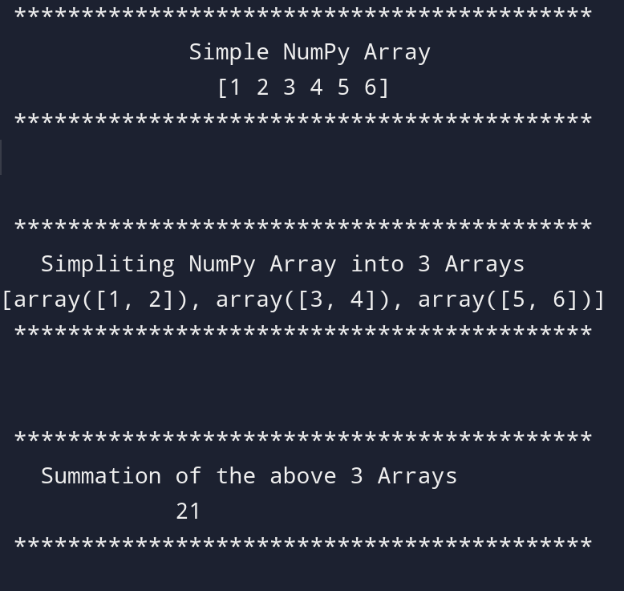

***2. Create a NumPy array to extract all numbers greater than 5 and less than 15.***

**Code:**

import numpy as np

print(" *******************************************")

print(" Simple Array ")

Array = np.array([5,23,13,11,9,7,2,1,0,8,10])

print(" ",Array)

print(" *******************************************")

print("\n")

print(" *******************************************************")

print(" Extracting numbers greater than 5 and less than 15 ")

filterd_Array = []

for x in Array:

if x > 5 and x<15:

filterd_Array.append(True)

else:

filterd_Array.append(False)

New_Array = Array[filterd_Array]

print(" ",New_Array)

print(" *******************************************************")

**Output:**

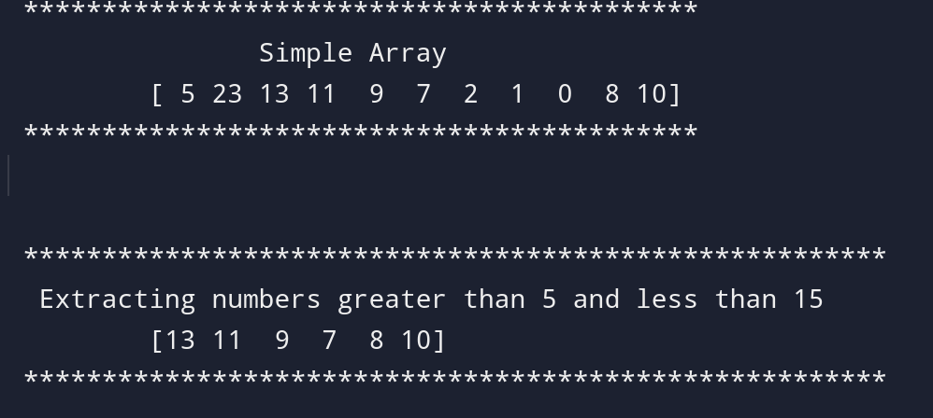

***3. Create two sets (at least one set through constructor)***

***set1 = {Even numbers (0~10)}***

***set2 = {Positive integers (1~10)}***

***a) Remove second and fifth element of set2***

***b) set3 = {intersection of set2 and set1}***

**Code:**

print("***********************************************")

print(" Even numbers 0-10 using a constructor")

set1 = set(range(0, 11, 2))

print(" ",set1)

print("***********************************************")

print("\n")

print("********************************************************")

print(" Positive integers 1-10 without using a constructor")

set2 = {1, 2, 3, 4, 5, 6, 7, 8, 9, 10}

print(" ",set2)

print("********************************************************")

print("\n")

print("********************************************************************")

print(" Positive integers 1-10 after removal ofsecond and fifth element ")

set2_list = list(set2)

set2_list.pop(1)

set2_list.pop(3)

print(" ",set2_list)

print("********************************************************************")

print("\n")

print("***********************************************")

print(" Intersection of set 1 and set 2")

set2 = set(set2_list)

set3 = set1.intersection(set2)

print(" ",set3)

print("***********************************************")

**Output:**

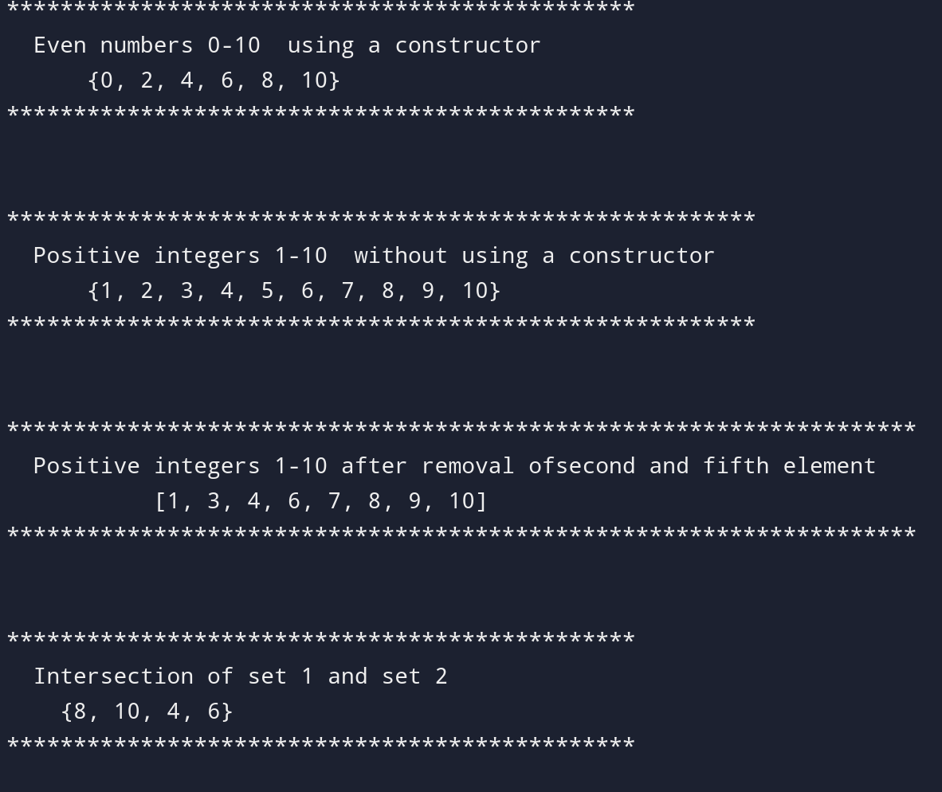

***4. Create a dictionary named “students”. Store 5 different students record into dictionary.***

***For key used sapId of the student. Student record should contain: sapid, name, age and***

***Semester (Six). Update the Semester (Six) to Semester (Seven)***

**Code:**

Students = {

56614: {"Name": "Kaleem", "Age": 19, "Semester": "Six"},

57362: {"Name": "Anas", "Age": 19, "Semester": "Six"},

53530: {"Name": "Arbaz", "Age": 21, "Semester": "Six"},

53098: {"Name": "Israr", "Age": 21, "Semester": "Six"},

56720: {"Name": "Haseeb", "Age": 20, "Semester": "Six"},

}

for student in Students.values():

if student["Semester"] == "Six":

student["Semester"] = "Seven"

print("******************************************************")

print(" Updated Student Records:")

print("******************************************************")

for sapId, record in Students.items():

print(f"SAP ID: {sapId}, Name: {record['Name']}, Age: {record['Age']}, Semester: {record['Semester']}")

print("******************************************************")

**Output:**

